**Task Analysis**

We selected test cases based on 6 criteria :

1. Annual Income : 2 test cases for high annual income, low income, mid range annual income each
2. Term : Selected 5 case each for both of the given term i.e 36, 60 months
3. Loan amount : 5 cases for high loan amount, low amount, mid range loan amount each
4. Purpose : Took a different case for each of the 10 purposes
5. State : Selected a case for each of the 50 states
6. Enquiries in Last 6 months : Selected 2 test cases for lower number enquiries, 2 for higher enquiries, and 2 for mid number of enquiries

Mape for each Models :

Linear Regression : 8.54

Neural Network : 5.75

Random Forest : 3.4

Amongst all of the three models we can see that Random Forest regressor gives us the best predictions. Given, any test case including the ones carried out by our team, the predicted values can be seen satisfactory as compared to the actual data of interest rates provided by the lending club. So if we test, our model, against any scenario, be risk averse, risk taking or any other scenario, our model will give a satisfactory predicted estimate of the interest rate.

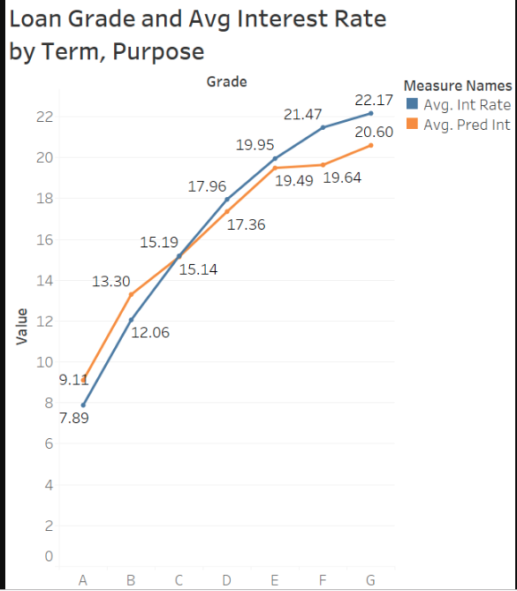

As we can see that based on the test case, the predicted interest rate line and the actual interest rate line provided by the model are closely aligned to each other providing the minimum error rate. Thus a client can be provided with a interest rate based on six criteria provided above.